PROFESSIONAL READINESS FOR INNOVATION, EMPLOYMENT AND ENTREPRENEURSHIP

# MEENAKSHI SUNDARARAJAN ENGINEERING COLLEGE

Kodambakkam, Chennai-600024.

## DEPARTMENT OF COMPUTER SCIENCE AND ENGINEERING

**TOPIC: Unleashing the Potential of Our Youth: A Student Performance Analysis**

TEAM ID : NM2023TMID07501

FACULTY MENTOR : S. Yamuna

INDUSTRY MENTOR: Shivam shivhare

Project submitted by,

|  |  |  |
| --- | --- | --- |
| **TEAM** | **NAME** | **REG. NO.** |
| Team Leader | Caroline Susanna S | 311520104013 |
| Team mate 2 | Muthulakshmi R | 311520104033 |
| Team mate 3 | Nivedha R | 311520104034 |
| Team mate 4 | Rakavi P | 311520104037 |

# ABSTRACT

Educational institutions rely on student performance analysis to evaluate student achievements, progress, and areas of improvement. The primary aim of student performance analysis is to evaluate individual student learning outcomes, identify patterns, and enable data-driven decision-making by educators, administrators, and policymakers. This overview covers different methodologies used in student performance analysis, such as traditional assessment methods, standardized testing, and innovative methods such as learning analytics and educational data mining. This project explores various methodologies employed in student performance analysis, including traditional assessment methods, standardized testing, and innovative approaches such as learning analytics and educational data mining. Furthermore, this project highlights key metrics commonly used in student performance analysis, including grades, test scores, attendance records, and behavioral indicators. It emphasizes the importance of considering multiple data points to gain a holistic understanding of student performance and to identify potential factors influencing academic success or challenges. The findings of this review emphasize the significance of student performance analysis in driving evidence-based educational practices. It underlines the need for data-driven decision-making to enhance teaching strategies, curriculum design, and educational policies. The abstract concludes by acknowledging the ongoing advancements in data analytics and technology that continue to reshape student performance analysis, paving the way for more effective and personalized educational experiences.

# Project Report Format

## INTRODUCTION

* 1. Project Overview
  2. Purpose

## LITERATURE SURVEY

* 1. Existing problem
  2. References
  3. Problem Statement Definition

## IDEATION & PROPOSED SOLUTION

* 1. Empathy Map Canvas
  2. Ideation & Brainstorming
  3. Proposed Solution
  4. Problem Solution fit

## REQUIREMENT ANALYSIS

* 1. Functional requirement
  2. Non-Functional requirements

## PROJECT DESIGN

* 1. Data Flow Diagrams
  2. Solution & Technical Architecture
  3. User Stories

## CODING & SOLUTION (Explain the features added in the project along with code)

* 1. Feature 1
  2. Feature 2
  3. Database Schema (if Applicable)

## RESULTS

* 1. Performance Metrics

## ADVANTAGES & DISADVANTAGES

1. **CONCLUSION**

## FUTURE SCOPE

1. **APPENDIX**

Source Code

GitHub & Project Demo Link

# INTRODUCTION

Data analysis is a field which focuses on extracting significant information, models and information from large data sets. It involves the application of various statistical, mathematical, and computational techniques to analyze and interpret data to support decision-making, uncover trends, and gain valuable insights. Data analytics converts raw data into actionable insights. It includes a range of tools, technologies, and processes used to find trends and solve problems by using data. Data analytics can shape business processes, improve decision-making, and foster business growth.

## How Data Analytics works?

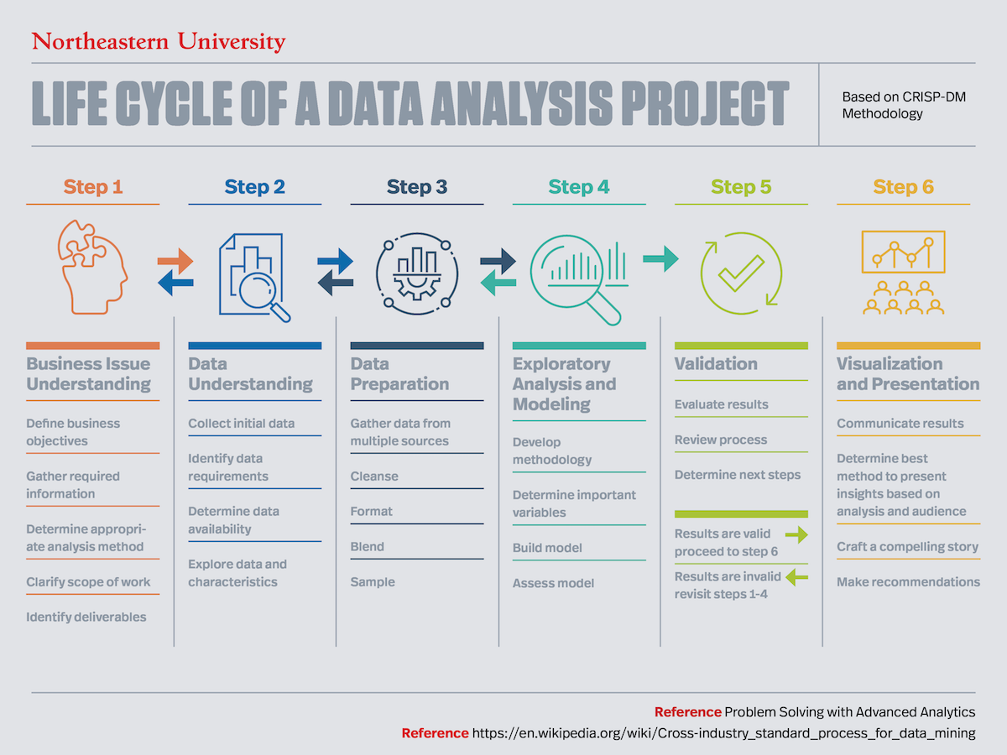

Data analytics involves a systematic approach to extracting insights and knowledge from data. The process typically begins with data collection from various sources, followed by data cleaning and preprocessing to ensure data quality and consistency. Once the data is ready, it is analyzed using a combination of statistical techniques, machine learning algorithms, and data visualization tools. Descriptive analytics helps to summarize and understand historical data patterns, while predictive analytics employs models to forecast future trends and outcomes. Prescriptive analytics goes a step further by providing recommendations or actions based on the insights gained. Throughout the analysis, iterative exploration and visualization of data aid in understanding and communicating the findings effectively. The ultimate goal of data analytics is to uncover valuable insights, make data-driven decisions, optimize processes, and drive meaningful business outcomes.

## 1.1 PROJECT OVERVIEW

The project aims to enhance the student performance analysis system in an educational institution to improve academic outcomes and support data-driven decision-making. By leveraging data analytics techniques, the project aims to gain insights into student performance, identify factors influencing academic success, and provide personalized interventions to support struggling students. The ultimate goal is to enhance the overall educational experience and foster academic excellence.

## PROJECT FLOW

1.Data Gathering: Collect dataset from the portal. Ensure data quality and consistency.

2.Data Preparation: Clean and preprocess the collected data, addressing missing values, inconsistencies, and outliers. Transform the data into a format suitable for analysis in IBM Cognos.

3.Data Integration: Integrate the cleaned data from various sources into a single data repository.This step ensures that all relevant student performance data is consolidated and readily accessible.

4. Data Modeling: Design and create data models in IBM Cognos. Establish relationships between different data elements to enable efficient querying and analysis.

5. Report and Dashboard Development: Utilize IBM Cognos Report Studio and Dashboarding capabilities to develop interactive reports and dashboards for student performance analysis. These visualizations should provide key insights into student achievements, progress, and areas of improvement.

6. Performance Metrics: Define the performance metrics and key performance indicators (KPIs) that will be used to assess student performance. These may include metrics such as average grades, test scores, attendance rates, or class participation.

7. Collaboration and Sharing: Enable collaboration and sharing capabilities within IBM Cognos to facilitate communication and knowledge sharing among stakeholders. This promotes data-driven decision-making and allows educators and administrators to work together in addressing student performance challenges.

8. Performance Monitoring and Evaluation: Continuously monitor student performance and evaluate the effectiveness of interventions. Measure the impact of implemented strategies on student outcomes and make necessary adjustments based on the insights gained.

9. Iterative Improvements: Continuously improve the student performance analysis system based on user feedback, emerging trends, and evolving educational needs. Incorporate new features, data sources, or analytics techniques to enhance the effectiveness and efficiency of the analysis process.

## 1.2 PURPOSE

The purpose of student performance analysis is to gain a comprehensive understanding of student performance using multiple data points such as grades, test scores, attendance records, and behavioral indicators. It helps teachers measure, manage, and evaluate student performance data, enabling them to optimize instruction for better learning outcomes. This can help understand the influence of important factors such as parental level of education and test preparation status on student performance. Ultimately, the integration of edutech and data analytics has the potential to optimize efficiency and offer students a seamless learning experience.

**2. IDEATION & PROPOSED SOLUTION**

**2.1 PROBLEM STATEMENT DEfiNITION**

The problem statement in student performance analysis pertains to the challenge of effectively  analyzing and understanding the factors influencing student performance in a given educational  context. This includes academic achievement, attendance, behavioral patterns, and other relevant  indicators. The problem lies in the inability to comprehensively assess and interpret student  performance data, resulting in difficulties in identifying patterns, predicting outcomes, and  implementing targeted interventions. Therefore, there is a pressing need for an efficient and robust  student performance analysis framework that can provide actionable insights, facilitate data-driven  decision-making, and enable the implementation of targeted interventions to improve student  performance and academic success.

**2.2 EMPATHY MAP CANVAS**

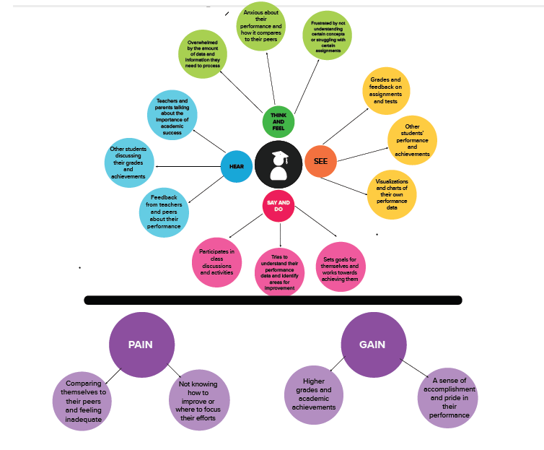

## 2.3 IDEATION & BRAINSTORMING

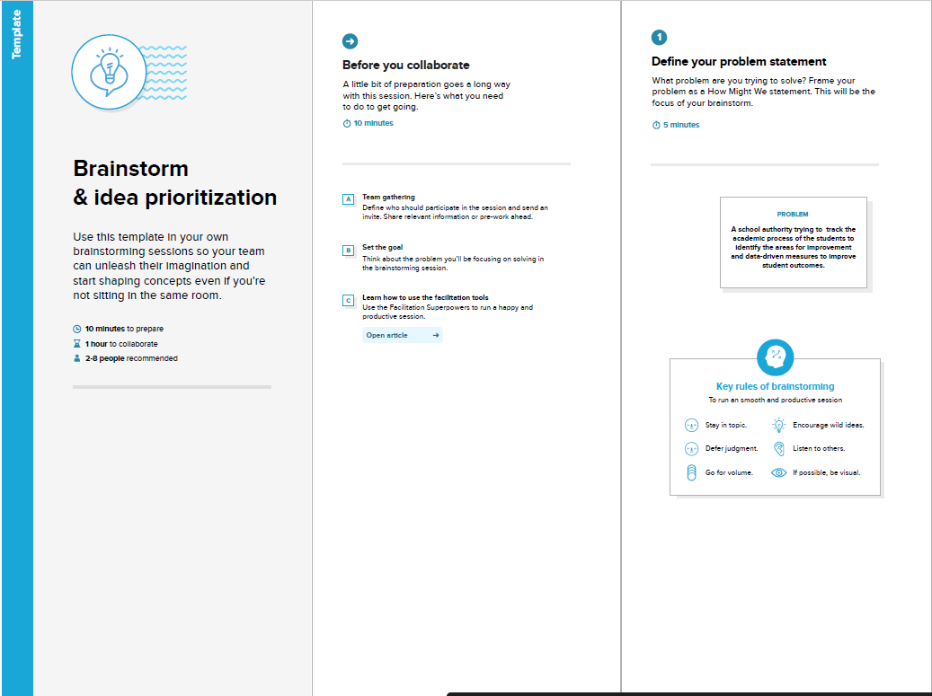

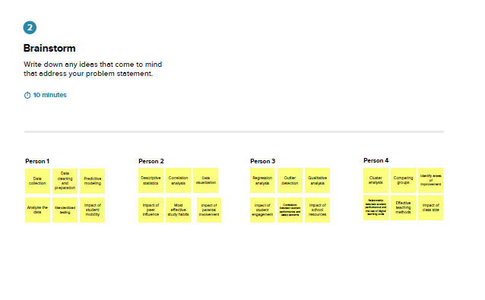

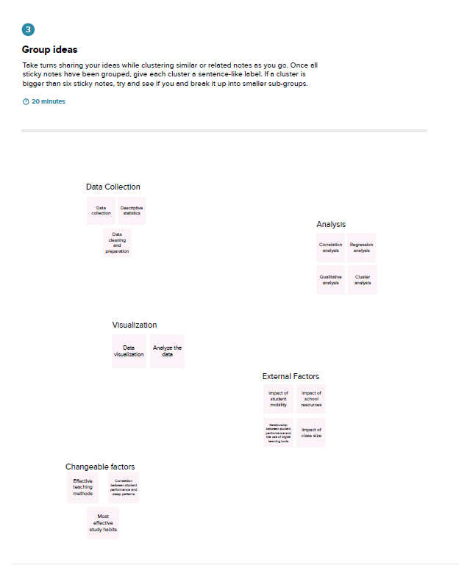

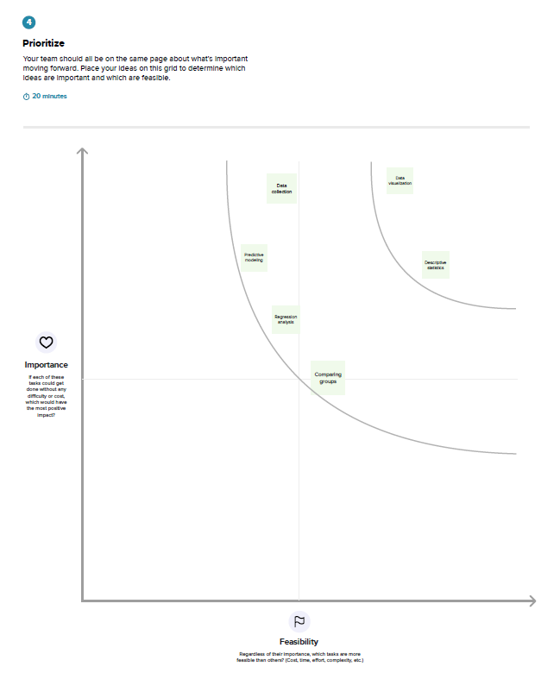

**2.4 PROPOSED SOLUTION**

|  |  |  |
| --- | --- | --- |
| **S.No.** | **Parameter** | **Description** |
| 1. | Problem Statement | The problem we are solving is to help  educational institutions and teachers to get  insights into the performance of their students.  By analyzing the performance of students,  educational institutions can identify the areas  where students are struggling and take  corrective measures to improve their  performance. |
| 2. | Solution description | Our solution is a student performance analysis  tool that uses data analytics to analyze the  performance of students. The tool collects data  from various sources such as exam results,  attendance records, and student feedback, and  uses this data to generate insights into the  performance of students. The tool provides  dashboards and reports that help teachers and  educational institutions to identify the areas  where students are struggling and take  corrective measures to improve their  performance. |
| 3. | Novelty/Uniqueness | Our solution is unique because it uses data  analytics to analyze the performance of  students. Our solution is also unique because it  is customizable and can be tailored to the  specific needs of each educational institution. |
| 4. | Social impact/ Customer satisfaction | Our solution has a significant social impact as it  helps to improve the performance of students  and increase their chances of success in their  careers. By providing insights into the  performance of students, our solution helps  teachers and educational institutions to identify  the areas where students are struggling and  take corrective measures to improve their  performance. This, in turn, leads to increased  student satisfaction and retention rates. |
| 5. | Business/ Revenue model | Educational institutions can subscribe to our  service and pay a monthly or annual fee to  access our student performance analysis tool.  We also offer customization services for an  additional fee. |
| 6. | Scalability of the solution | Our solution is highly scalable as we can easily  add new features and functionalities to our tool  to meet the evolving needs of educational  institutions. We can provide support and  assistance to our customers |

## PROBLEM SOLUTION FIT

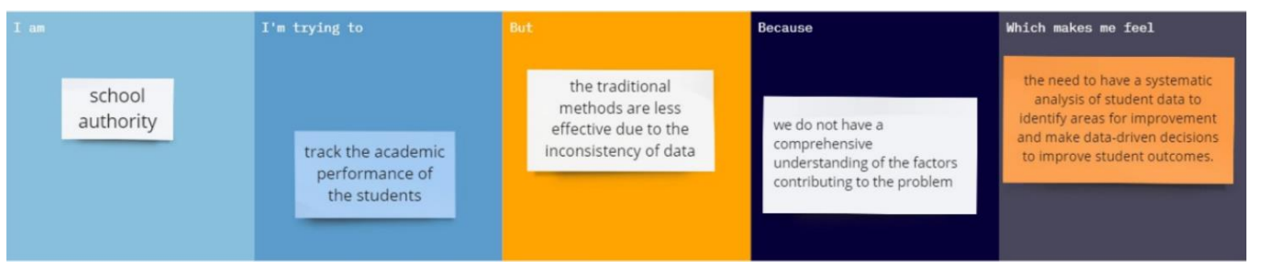

I am school authority. I’m trying to track the academic performance of students but the traditional methods are less effective due to the inconsistency of data because we do not have comprehensive understanding of the factors contributing to the problem which makes me feel the need to have a systematic analysis of student data to identify areas for improvement and make data-driven decisions to improve student outcomes.

**3. REQUIREMENT ANALYSIS**

**3.1 FUNCTIONAL REQUIREMENTS**

|  |  |  |
| --- | --- | --- |
| **FRNo.** | **Functional Requirement (Epic)** | **Sub Requirement(Story/Sub-Task)** |
| FR-1 | Performance Dashboard | Integration with the student information system(real time data)  Track trends and compare the performance across different classes |
| FR-2 | Report Generation | Clear presentation of data  Data accuracy  Timeliness |
| FR-3 | Parent Portal | User-friendly interface  Notifications and alerts |
| FR-4 | Student Portal | Goal-setting tools  Personalized information |
| FR-5 | Assessment and Evaluation Tool | Validity and reliability  Clear grading criteria  Individualized feedback |

**3.2 NON-FUNCTIONAL REQUIREMENTS**

|  |  |  |
| --- | --- | --- |
| **FRNo.** | **Non-FunctionalRequirement** | **Description** |
| NFR-1 | Usability | Usability plays a critical role in student performance analysis, as it impacts user adoption, data accuracy, user satisfaction, efficiency, accessibility, training requirements, collaboration, and decision-making. |
| NFR-2 | Security | Data protection, confidentiality, user authentication, data backup and recovery will be done in a good manner. |
| NFR-3 | Reliability | Reliability ensures that the data and information provided by the analysis are accurate, consistent, and dependable. |
| NFR-4 | Performance | Performance in student performance analysis is to measure and evaluate how well a student is performing in a particular subject or skill area. |
| NFR-5 | Availability | The role of availability in student performance analysis is to ensure that the necessary data and resources are accessible and reliable. By ensuring availability, stakeholders can perform effective analysis, make informed decisions, and support student success. |
| NFR-6 | Scalability | Scalability in student performance analysis is to ensure that the system can handle increasing amounts of data and users without sacrificing performance or reliability. |

**4. PROJECT DESIGN**

**4.1 DATA FLOW DIAGRAMS**

A data flow diagram (DFD) for student performance analysis would depict the flow of data and processes involved in analyzing and evaluating student performance within an educational system. The DFD can be expanded or decomposed further based on the specific requirements and processes involved in the student performance analysis system. It provides a visual representation of how data flows through various processes and entities, facilitating understanding, analysis, and communication among stakeholders involved in monitoring and improving student performance.

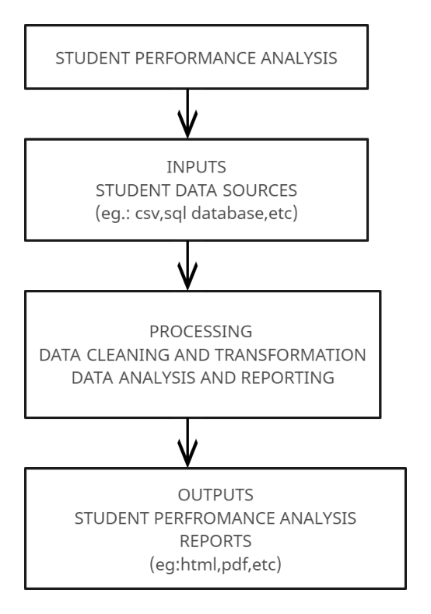**DFD LEVEL 0**

**DFD LEVEL 1**

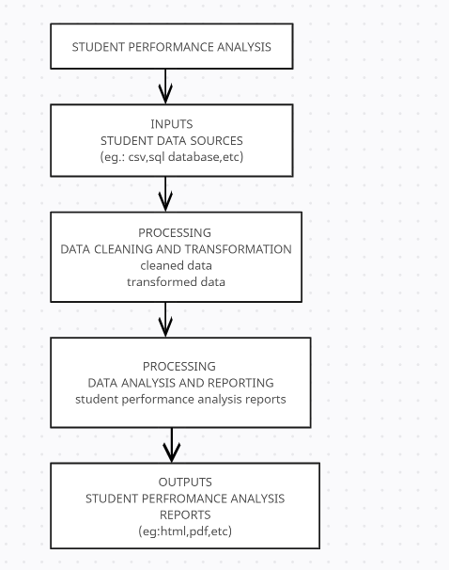

**DFD LEVEL 2**

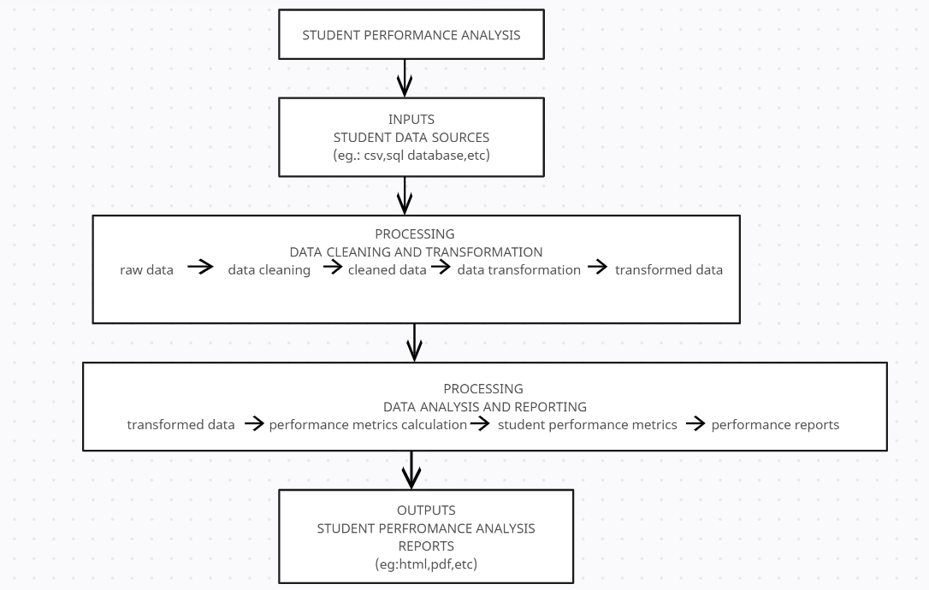

## 4.2 SOLUTION ARCHITECTURE AND TECHNICAL ARCHITECTURE

## SOLUTION ARCHITECTURE

• Our solution is a student performance analysis tool that uses data analytics to analyze the performance of students. The tool collects data from various sources such as exam results, attendance records, and student feedback, and uses this data to generate insights into the performance of students. The tool provides dashboards and reports that help teachers and educational institutions to identify the areas where students are struggling and take corrective measures to improve their performance.

• Our solution is unique because it uses data analytics to analyze the performance of students. Our solution is also unique because it is customizable and can be tailored to the specific needs of each educational institution and provides specifications according to which the solution is defined, managed, and delivered.

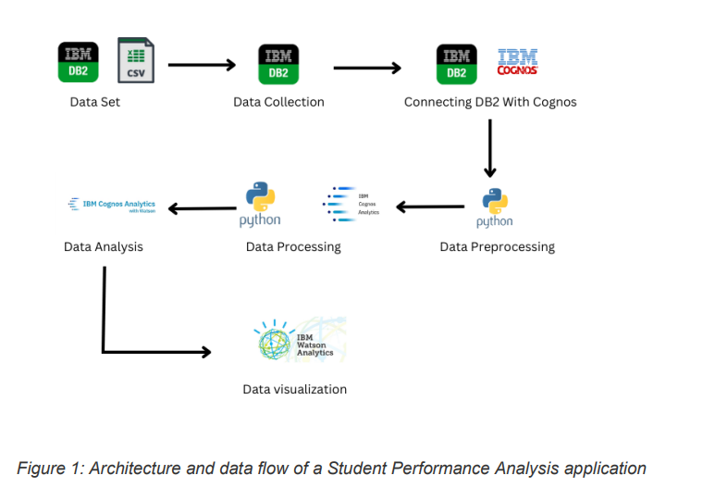

## Solution Architecture

**TECHNICAL ARCHITECTURE:**

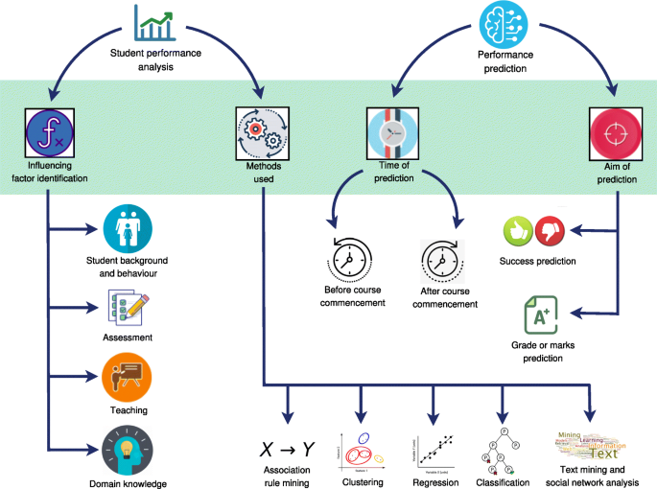

**Technical Architecture**

## Table-1 :

**Components & Technologies:**

|  |  |  |  |
| --- | --- | --- | --- |
| **S.No** | **Component** | **Description** | **Technology** |
|  | User Interface | How user interacts with application e.g.  Web UI, Mobile App, Chatbot etc. | HTML, CSS, JavaScript, React JS |
|  | Application Logic-1 | Data Preprocessing and Cleaning | Python (Pandas, Numpy) |
|  | Application Logic-2 | Predictive Analytics | Python (Scikit-Learn, XGBoost) |
|  | Application Logic-3 | Natural Language Processing | IBM Watson Assistant |
|  | Database | Data Type, Configurations | IBM DB2 |
|  | Cloud Database | Database Service on Cloud | IBM DB2, IBM Cloudant etc. |
|  | File Storage | File storage requirements | IBM Block Storage or Other Storage Service or Local Filesystem |
|  | External API-1 | Education Data API | National Center for Education Statistics (NCES) API |
|  | External API-2 | Location Data API | Google Maps API |
|  | Machine Learning Model | Supervised Learning Model | Random Forest, Support Vector Machine (SVM) |
|  | Infrastructure (Server / Cloud) | Application Deployment on Cloud | IBM Cloud, Github |

## Table-2:

**Application Characteristics:**

| **S.No** | **Characteristics** | **Description** | **Technology** |
| --- | --- | --- | --- |
|  | Open-Source Frameworks | List the open-source frameworks used | Pandas, NumPy |
|  | Security Implementations | List all the security / access controls implemented, use of firewalls etc. | HTTPS |
|  | Scalable Architecture | Justify the scalability of architecture (3 – tier, Micro-services) | Docker |
|  | Availability | Justify the availability of application (e.g. use of load balancers, distributed servers etc.) | Kubernetes |
|  | Performance | Design consideration for the performance of the application (number of requests per sec, use of Cache, use of CDN’s) etc. | Redis |

**4.3 USER STORIES**

**PROJECT PLANNING & SCHEDULING**

**User Stories**

|  |  |  |  |  |  |  |
| --- | --- | --- | --- | --- | --- | --- |
| **USER TYPE** | **FUNCTIONAL REQUIREMENT** | **USER STORY**  **NUMBER** | **USER STORY/TASK** | **ACCEPTANCE CRITERIA** | **PRIORITY** | **TEAM MEMBER** |
| Teacher | Performance Dashboard | US001 | As a teacher, I want to be able to see the grades and overall performance of all my students in a particular class, so that I can identify areas of strength and weakness and adjust my teaching approach accordingly. | 1. The performance dashboard displays all students in the selected class with their corresponding grades and overall performance. <br>  2. The performance dashboard can be filtered and sorted based on different criteria such as grade level, gender, or performance level. <br>  3. The performance dashboard provides a user-friendly interface such as a table or chart. | High | Muthulakshmi R |
| School Administrator | Report Generation | US002 | As a school administrator, I want to be able to generate reports on student performance over time, so that I can track trends and identify areas of improvement or concern. | 1. The report generation feature allows the user to select parameters such as time range, student groups, and subject areas. <br>  2. The generated report presents the retrieved data in a user-friendly format such as a table or chart. <br>  3. The generated report can be exported in a variety of formats such as PDF or CSV. <br>  4. The generated report can be filtered and sorted based on different criteria such as grade level, gender, or performance level. | Medium | Ameenath Famida D M |
| Parent | Parent Portal | US003 | As a parent, I want to be able to see my child's grades and overall performance in each subject, so that I can monitor their progress and provide support where needed | 1. The parent portal allows parents to access their child's performance data. <br>  2. The parent portal displays the child's grades and overall performance in each subject. <br>  3. The parent portal provides a user-friendly interface such as a table or chart. <br> 4. The parent portal can be filtered and sorted based on different criteria such as grade level, subject, or performance level. | Medium | Swathi Priya S G |
| Student | Student Portal | US004 | As a student, I want to be able to see my own grades and overall performance, so that I can track my progress and identify areas where I need to improve. | 1. The student portal allows students to access their own performance data.  2. The student portal displays the student's grades and overall performance in each subject.  3. The student portal provides a user-friendly interface such as a table or chart. | Medium | Swetha P |

**5.CODING & SOLUTIONING**

**5.1 FEATURE 1**:

IBM Cognos (dashboard, story, report) - Utilizing IBM Cognos, the project enables the creation of visually appealing dashboards, interactive stories, and detailed reports for comprehensive student performance analysis.

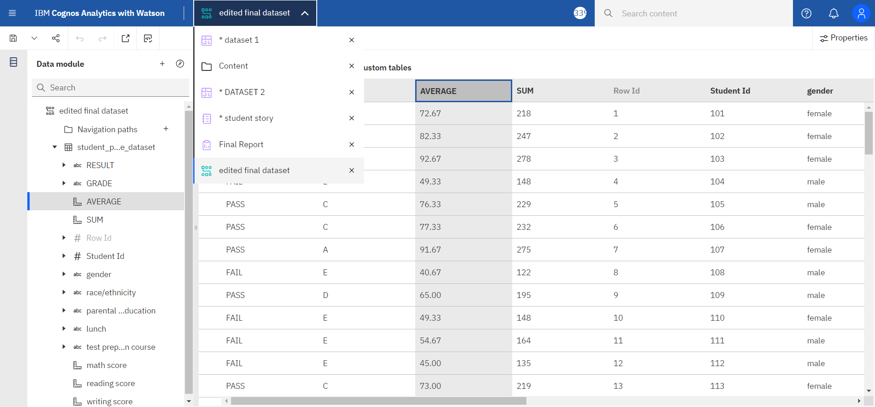

**5.2 FEATURE 2**:

Python Flask Application - The project incorporates a Python Flask application to provide a user-friendly and responsive interface for accessing and interacting with the student performance data, enhancing the overall user experience.

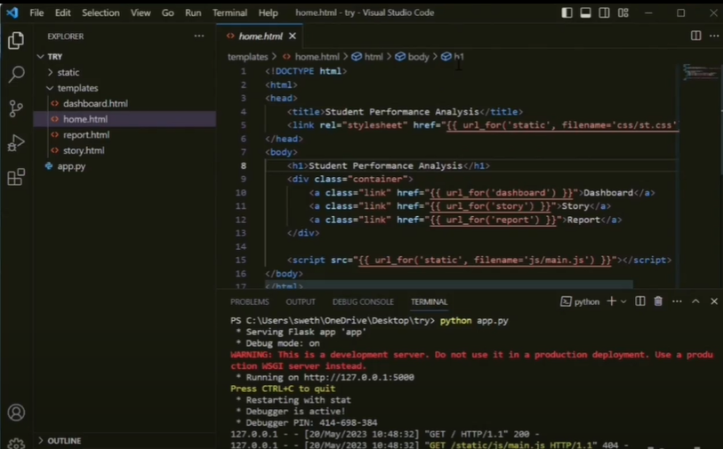

**5.3 FEATURE 3:**

Webpage- A webpage for student data analysis provides an interactive and user-friendly interface for analyzing and exploring student performance data. It allows educators, administrators, and other stakeholders to access and analyze student data to gain insights, track progress, and make informed decisions. Here's a description of the key components and features that could be included on a we 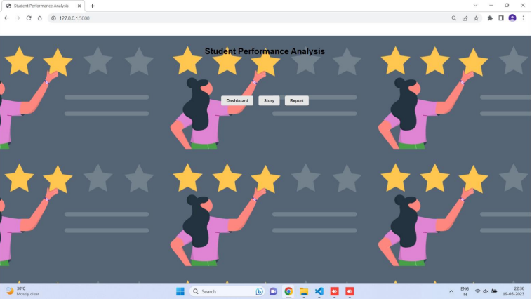

**5.4 FEATURE 4:**

Dashboard: A dashboard for student data analysis provides a visual representation of key metrics and insights derived from student performance data. It allows educators, administrators, and other stakeholders to monitor and assess student progress, identify areas of improvement, and make data driven decisions.

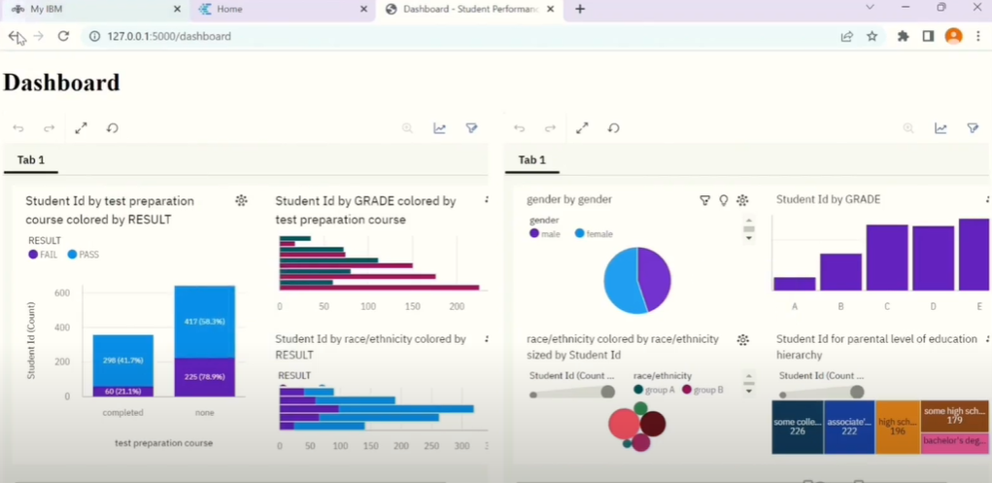

**5.5 FEATURE 5:**

Story – The story highlights the impact of leveraging student data to improve educational outcomes and create a nurturing environment for student success.

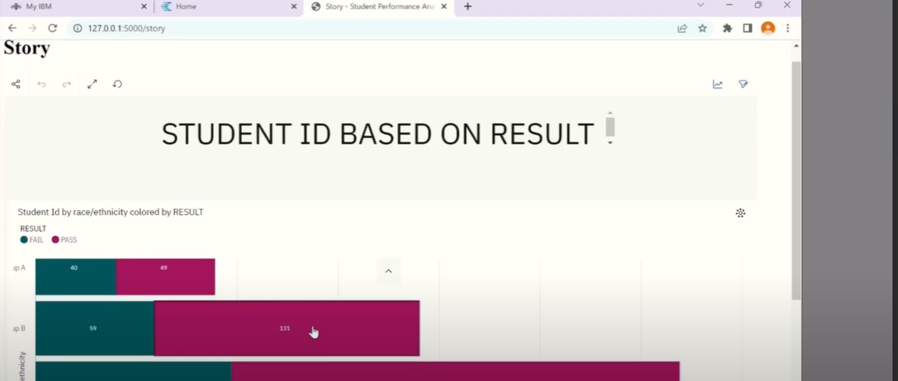

**5.6 FEATURE 6:**

Report – This report highlights key findings, trends, and insights derived from the analysis of student data, enabling stakeholders to make informed decisions and take targeted actions to improve educational outcomes.The report begins with an executive summary, presenting a concise overview of the main findings and recommendations. It provides a high-level snapshot of student performance, identifying notable achievements, challenges, and areas requiring further attention.

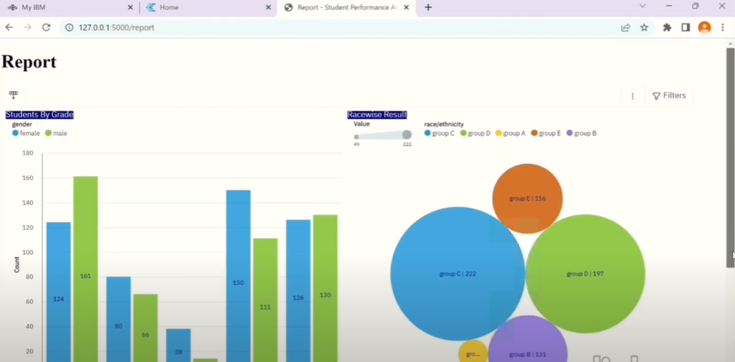

**6.RESULTS**

**6.1 PERFORMANCE METRICS**

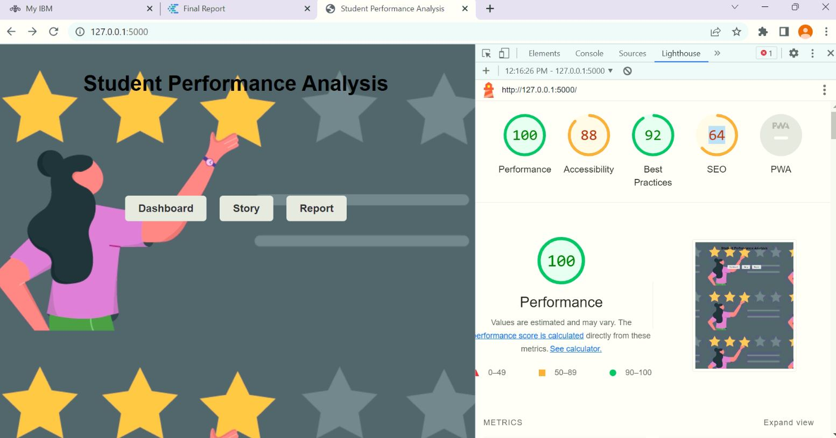

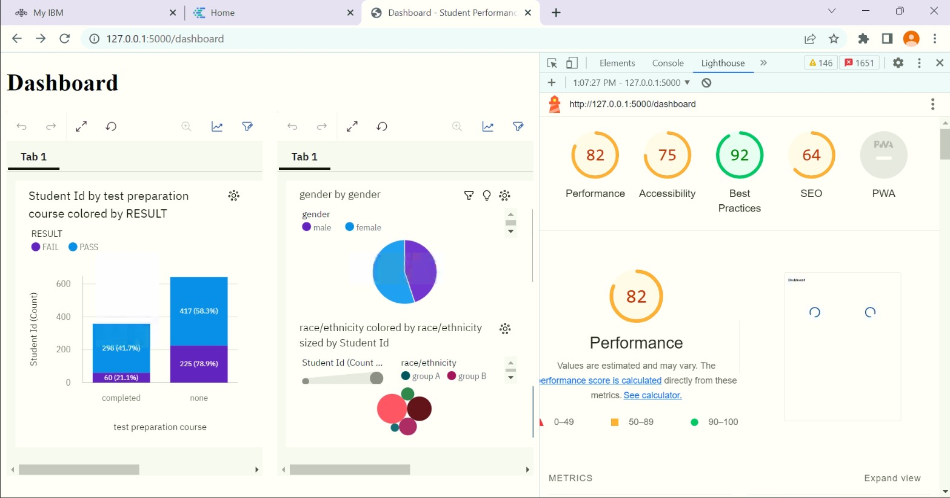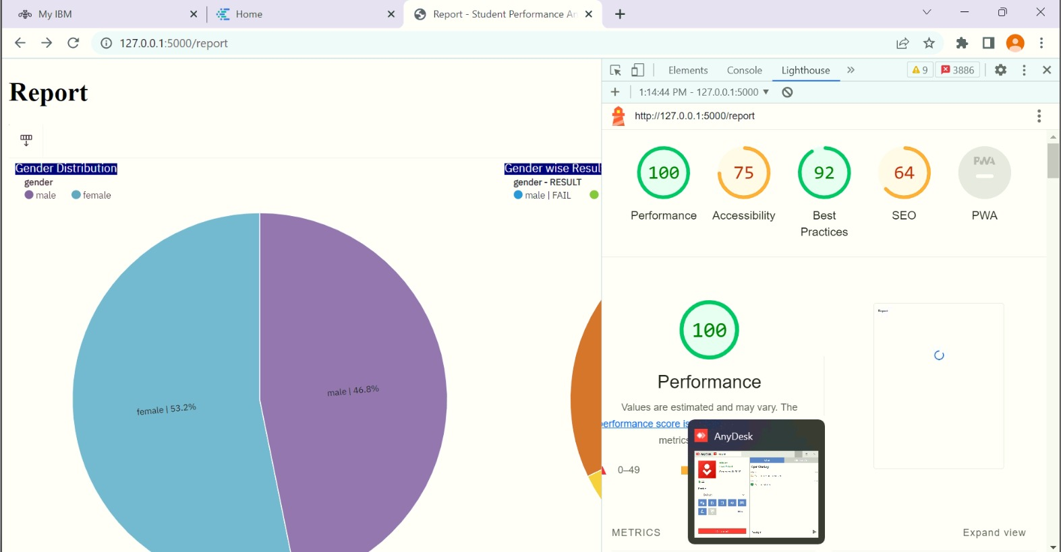

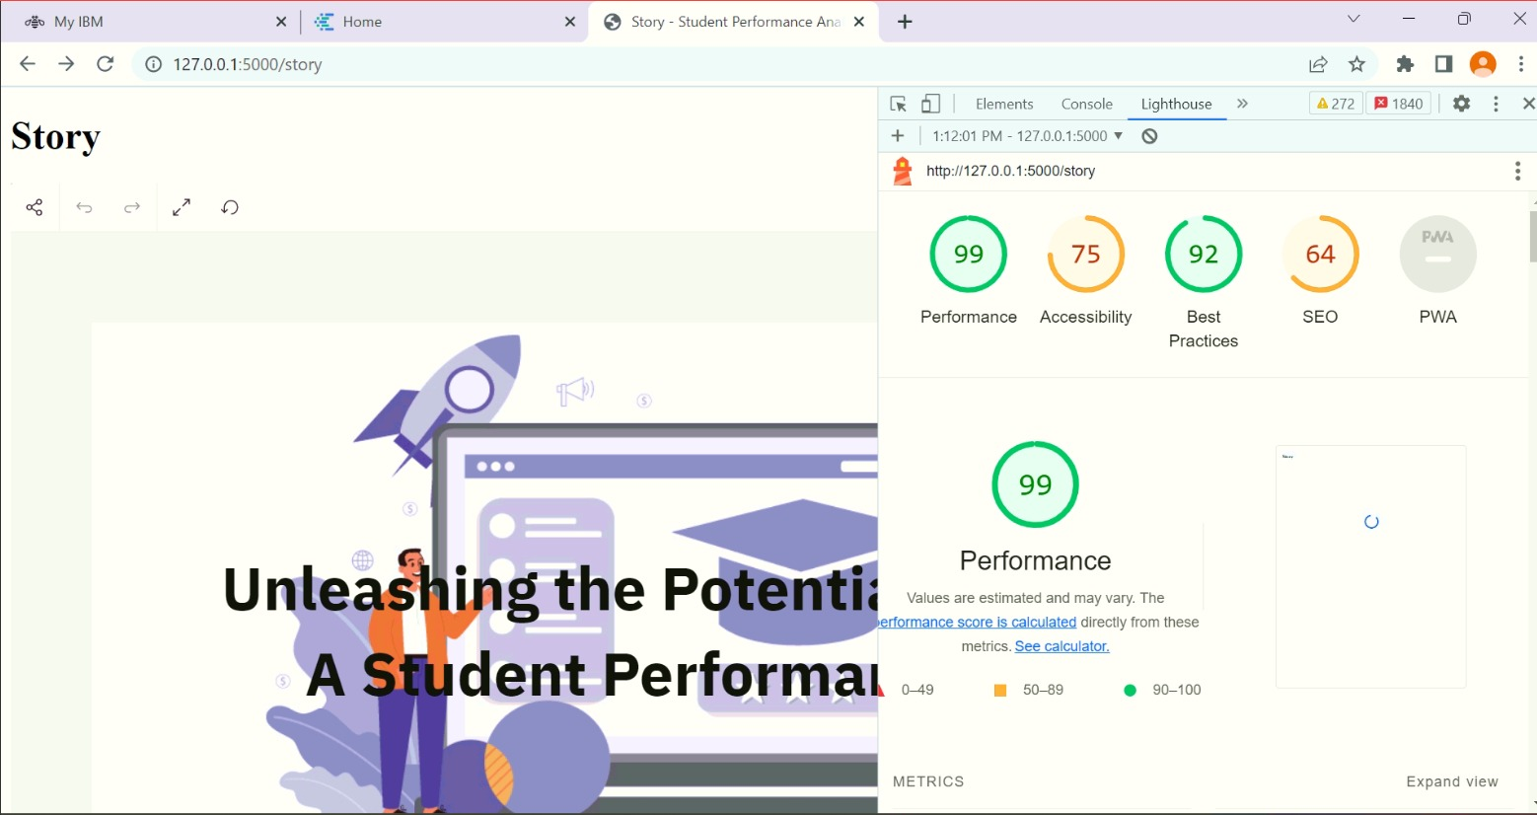

## 7.ADVANTAGES & DISADVANTAGES:

## ADVANTAGES:

## 1. Comprehensive Data Analysis: The project allows for in-depth analysis of student performance through IBM Cognos, enabling educators to gain valuable insights and make data-driven decisions.

## 2. Interactive Visualization: The use of IBM Cognos dashboards and stories facilitates interactive data visualization, making it easier to understand and communicate complex information.

## 3. User-Friendly Interface: The Python Flask application provides a user-friendly interface, allowing educators and administrators to easily navigate and access student performance data.

## 4. Customizability: Both IBM Cognos and Python Flask offer customization options, enabling the project to be tailored to the specific needs and requirements of educational institutions.

## 5. Scalability: The project can be scaled up to accommodate large amounts of data and additional features, making it suitable for educational institutions of varying sizes.

## DISADVANTAGES:

## 1. Complexity: Implementing and maintaining an IBM Cognos and Python Flask-based project can be complex, requiring expertise in both technologies and potentially posing challenges for less tech-savvy users.

## 2. Cost: IBM Cognos is a commercial tool that may involve licensing and subscription costs, which could be a potential financial burden for smaller educational institutions with limited budgets.

## 3. Integration Challenges: Integrating the project with existing systems and databases may present challenges, requiring thorough planning and coordination to ensure smooth data flow and compatibility.

## 8.CONCLUSION

In conclusion, student performance analysis plays a critical role in understanding and improving academic outcomes. By analyzing various factors that influence student achievement, such as individual abilities, motivation, and learning environments, educators can gain valuable insights into students' strengths and weaknesses. This analysis enables evidence-based decision-making, allowing educators to identify areas for improvement, implement targeted interventions, and allocate resources effectively. Additionally, student performance analysis helps identify achievement gaps and promotes equity in education by addressing disparities among student groups. By continuously monitoring progress and measuring the impact of interventions, educational institutions can ensure that all students have equal opportunities for success. Ultimately, student performance analysis serves as a powerful tool for optimizing teaching strategies, improving learning outcomes, and creating a supportive and inclusive educational environment.

## 

## 9.FUTURE SCOPE

## The future scope for student performance analysis holds great potential for further advancements and innovations. With the rapid development of technology and data analytics, student performance analysis can leverage new tools and methodologies to provide more comprehensive and accurate insights. Machine learning algorithms and artificial intelligence can be employed to analyze large datasets, identify complex patterns, and generate personalized recommendations for students. Additionally, the integration of multiple data sources, such as academic records, assessment scores, attendance records, and even social and emotional data, can provide a more holistic view of student performance.

## 10 .APPENDIX

**SOURCE CODE**

**app.py**

from flask import Flask, render_template

app = Flask(__name__)

@app.route('/')

def home():

return render_template('home.html')

@app.route('/story')

def story():

return render_template('story.html')

@app.route('/dashboard')

def dashboard():

return render_template('dashboard.html')

@app.route('/report')

def report():

return render_template('report.html')

if __name__ == '__main__':

app.run(debug=True)

**st.css**

body {

font-family: Arial, sans-serif;

margin: 0;

padding: 20px;

background-image: url("https://kissflow.com/hubfs/Performance-evaluation-questions.png");

background-size: auto;

background-position: center;

}

h1 {

text-align: center;

}

.container {

display: flex;

justify-content: center;

align-items: center;

height: 300px;

}

.link {

display: inline-block;

margin: 10px;

padding: 10px 20px;

background-color: #e6e6e6;

border-radius: 5px;

text-decoration: none;

color: #333;

font-weight: bold;

}

**dashboard.html:**

<!DOCTYPE html>

<html>

<head>

<title>Dashboard - Student Performance Analysis</title>

<style>

.embed-container {

display: grid;

grid-template-columns: repeat(2, 1fr); /* Adjust the number of columns as needed */

gap: 20px;

}

.embed-container iframe {

width: 100%;

height: 500px;

border: none;

}

</style>

</head>

<body>

<h1>Dashboard</h1>

<div class="embed-container">

<!-- Paste your IBM Cognos Analytics embedding code for the first Dashboard file here -->

<iframe src="https://us3.ca.analytics.ibm.com/bi/?perspective=dashboard&amp;pathRef=.my_folders%2FDATASET%2B2&amp;closeWindowOnLastView=true&amp;ui_appbar=false&amp;ui_navbar=false&amp;shareMode=embedded&amp;action=view&amp;mode=dashboard&amp;subView=model000001882e44210c_00000002" width="1200" height="800" frameborder="0" gesture="media" allow="encrypted-media" allowfullscreen=""></iframe>

<!-- Paste your IBM Cognos Analytics embedding code for the second Dashboard file here -->

<iframe src="https://us3.ca.analytics.ibm.com/bi/?perspective=dashboard&amp;pathRef=.my_folders%2Fdataset%2B1&amp;closeWindowOnLastView=true&amp;ui_appbar=false&amp;ui_navbar=false&amp;shareMode=embedded&amp;action=view&amp;mode=dashboard&amp;subView=model000001882e41911b_00000001" width="1200" height="800" frameborder="0" gesture="media" allow="encrypted-media" allowfullscreen=""></iframe>

</div>

</body>

</html>

**home.html**

<!DOCTYPE html>

<html>

<head>

<title>Student Performance Analysis</title>

<link rel="stylesheet" href="{{ url_for('static', filename='css/st.css') }}">

</head>

<body>

<h1>Student Performance Analysis</h1>

<div class="container">

<a class="link" href="{{ url_for('dashboard') }}">Dashboard</a>

<a class="link" href="{{ url_for('story') }}">Story</a>

<a class="link" href="{{ url_for('report') }}">Report</a>

</div>

<script src="{{ url_for('static', filename='js/main.js') }}"></script>

</body>

</html>

**report.html**

<!DOCTYPE html>

<html>

<head>

<title>Report - Student Performance Analysis</title>

</head>

<body>

<h1>Report</h1>

<div class="embed-container">

<iframe src="https://us3.ca.analytics.ibm.com/bi/?pathRef=.my_folders%2FFinal%2BReport&amp;closeWindowOnLastView=true&amp;ui_appbar=false&amp;ui_navbar=false&amp;shareMode=embedded&amp;action=run&amp;format=HTML&amp;prompt=false" width="1200" height="800" frameborder="0" gesture="media" allow="encrypted-media" allowfullscreen=""></iframe>

</div>

</body>

</html>

**story.html**

<!DOCTYPE html>

<html>

<head>

<title>Story - Student Performance Analysis</title>

</head>

<body>

<h1>Story</h1>

<div class="embed-container">

<iframe src="https://us3.ca.analytics.ibm.com/bi/?perspective=story&amp;pathRef=.my_folders%2Fstudent%2Bstory&amp;closeWindowOnLastView=true&amp;ui_appbar=false&amp;ui_navbar=false&amp;shareMode=embedded&amp;action=view&amp;sceneId=model000001882e53f0cc_00000007&amp;sceneTime=0" width="1200" height="800" frameborder="0" gesture="media" allow="encrypted-media" allowfullscreen=""></iframe>

</div>

</body>

</html>

**GITHUB LINK:**

<https://github.com/Carolsankho/Naan-Mudhalvan>

**PROJECT VIDEO DEMO LINK:**

https://drive.google.com/drive/folders/1lfqHFYrLPKcPaapDyRHNT_5xfJ-h7RyV